**REALATIONAL SCHEMA**

PROJECT TITLE:

FIND YOURSELF A MENTOR

Group Name:

INTELLECTUALS

MEMBERS:

1)Mahnoor Maleeka Shehzad (2020217).

2) Saad Khan (2020414).

UNIVERSITY:

|  |  |  |
| --- | --- | --- |
| ID | NAME | LOCATION |
| 01 | GIKI | Topi |
| 02 | OTHER | Other |

GIKIANS:

|  |  |  |  |  |  |  |  |
| --- | --- | --- | --- | --- | --- | --- | --- |
| REG_NO | ID(F) | USERNAME | HASH | EMAIL | NAME | YEAR | FACULTY |
| 2018001 | 01 | lucy_K | #EF1`23* | morningstar@hell.com | Lucifer | 4 | FCSE |
| 2019001 | 01 | amal1 | #FA*SD2 | amal@gmail.com | Amal | 3 | FME |
| 2020001 | 01 | dean_ | #XVZX*C | [dean@gmail.com](mailto:dean@gmail.com) | Dean | 2 | FCSE |
| 2020002 | 01 | sammy | #123`VXC | [sam@gmail.com](mailto:sam@gmail.com) | Sam | 2 | FME |
| 2021001 | 01 | amy2 | #5546^H | [amy@gmail.com](mailto:amy@gmail.com) | Amy | 1 | FEE |
| 2021002 | 01 | A_li | #YKJN_D | [ali@gmail.com](mailto:ali@gmail.com) | Ali | 1 | FCVE |

GIKI_SOCIETIES:

|  |  |
| --- | --- |
| REG_NO(F) | SOCITIES |
| 2018001 | LES |
| 2018001 | SOPHEP |
| 2019001 | MEDIA |
| 2019001 | IMECHE |
| 2020001 | ACM |
| 2020001 | IET |
| 2020002 | MEDIA |
| 2021001 | IEEE |
| 2021001 | LES |
| 2021001 | SCIENCE |
| 2021002 | IMECHE |

GIKI_TEAMS:

|  |  |
| --- | --- |
| REG_NO(F) | TEAMS |
| 2018001 | Technobolt |
| 2019001 | Invictus |
| 2020001 | Hammerhead |
| 2020002 | Foxtrot |
| 2020002 | Urban |
| 2021001 | Infinity |
| 2021002 | Invictus |

MENTOR:

|  |  |
| --- | --- |
| REG(F) | YEAR(F) |
| 2018001 | 4 |
| 2019001 | 3 |

MENTEES_OF_MENTORS:

|  |  |
| --- | --- |
| REG(F) | MEN_ID(F) |
| 2018001 | 2020001 |
| 2018001 | 2021001 |
| 2019001 | 2021002 |
| 2019001 | 2020002 |

MENTOR_BEST_COURSES:

|  |  |
| --- | --- |
| REG(F) | BEST_COURSES |
| 2018001 | Data Structures |
| 2018001 | EDC |
| 2018001 | COAL |
| 2019001 | Engineering Graphics |
| 2019001 | Calculus |
| 2019001 | Statics |

MENTOR_SKILLS:

|  |  |
| --- | --- |
| REG(F) | SKILLS |
| 2018001 | Web development |
| 2018001 | Photoshop |
| 2018001 | Programming |
| 2019001 | CAD |
| 2019001 | Video Editing |
| 2019001 | PCB Desinging |

MENTEES:

|  |  |  |
| --- | --- | --- |
| reg(F) | MENTOR_ID(F) | YEAR(F) |
| 2020001 | 2018001 | 2 |
| 2020002 | 2019001 | 2 |
| 2021001 | 2018001 | 1 |
| 2021002 | 2019001 | 1 |

MENTEE_WEAK_COURSES:

|  |  |
| --- | --- |
| reg(F) | WEAK_COURSES |
| 2020001 | Calculus |
| 2020001 | Data Structures |
| 2020002 | Statics |
| 2020002 | Dynamics |
| 2021001 | EDC |
| 2021002 | Engineering Graphics |
| 2021002 | Calculus |

MENTEE_INTERESTS:

|  |  |
| --- | --- |
| reg(F) | INTERESTS |
| 2020001 | Photoshop |
| 2020001 | Programming |
| 2020002 | PCB Designing |
| 2020002 | CAD |
| 2021001 | Web development |
| 2021001 | PCB Designing |
| 2021002 | Video Editing |
| 2021002 | MATLAB |

**SCHEMA**

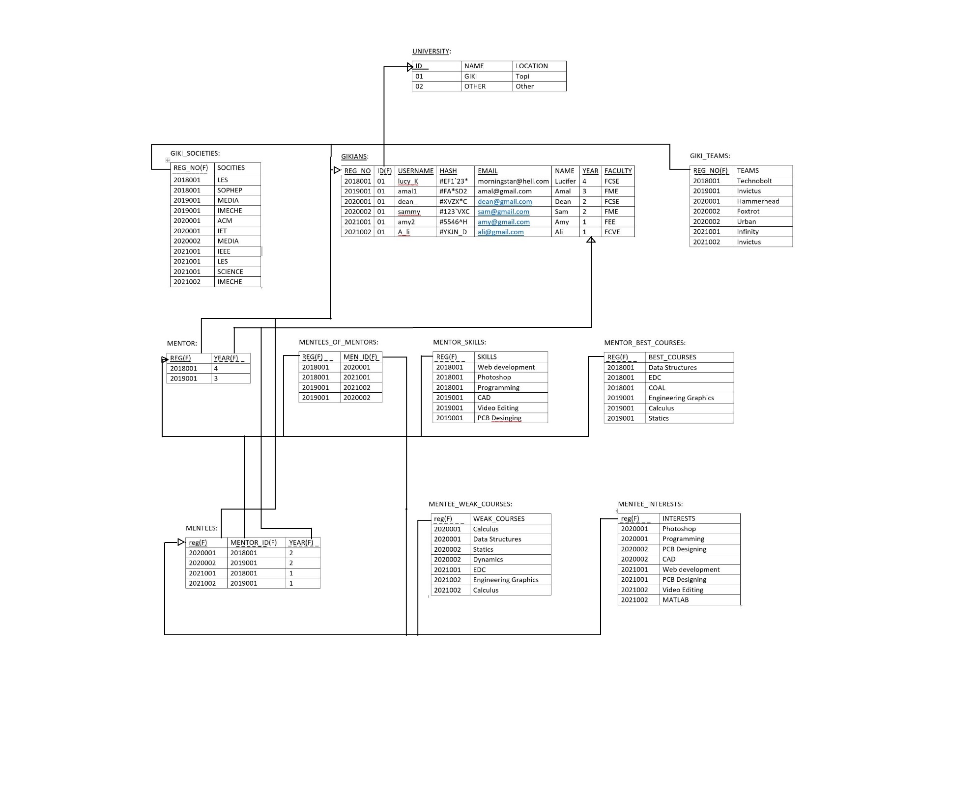

**Assumptions:**

1. A Gikian can have a maximum of three societies and 2 two teams.
2. A Mentor can have a maximum of three skills and can have up to 3 best courses.
3. A Mentee can have a maximum of three interests and can have up to 3 weak courses.
4. A Mentor can have maximum of only three Mentees.
5. The tables are already normalized.
6. The dummy data includes 2 Mentors, each having two Mentees. Four in total.